

|  |  |
| --- | --- |
| **Teaching the Principle of Sunscreen Material using ZnO, TiO2, SiO2, Al2O3, and CeO2 to Elementary School Students**  ***Yusup Maulana(a), Wahyu Sopandi(a), Asep Kadarohman(b),***  ***Asep Bayu Dani Nandiyanto(b)\****  *(a) Department Elementary Education, Universitas Pendidikan Indonesia, Jl. Dr. Setiabudhi No.229, Bandung Indonesia*  *(b) Department Chemistry, Universitas Pendidikan Indonesia, Jl. Dr. Setiabudhi No.229, Bandung Indonesia* | |
|  |  |
| *\* Corresponding author:*  *agis@email.unikom.ac.id*  *Received ,*  *Revised ,*  *Accepted* | **Abstract**  This study aims to analyze the experimental demonstration teaching method using video on elementary school students’ science learning outcomes and identify the principle of sunscreen using various materials against the sun. The principle of sunscreen is taught using photo paper smeared with a light-sensitive liquid. After that, the sunscreen material is dripped on the paper, coated with transparent plastic, exposed to sunlight, and observed for changes. To analyze the physical properties in the morphology of the sunscreen material observations with SEM and XRD. Students’ understanding is assessed through a 20-pretest posttest question supported by a learning video, where the research subjects are 23 elementary school students in Indonesia. The results show that the principle of sunscreen material using ZnO, TiO2, SiO2, Al2O3, and CeO2 can keep the light-sensitive paper from changing color after being exposed to sunlight. There was an increase in students' understanding of the principle of sunscreen material after being given a learning video. This study shows and useful for informing the principle of sunscreen using various materials and students' understanding of it. |
|  |  |
| ***Keywords:*** *Sunscreen material, Elementary school, Teaching, Ultraviolet rays* | |

**1. Introduction**

UV radiation that is too long on the skin can cause skin diseases such as skin cancer and allergic reactions to light/photoallergy [1]. UV radiation can be divided into UV A, UV B, and UV C. UV C can be absorbed by ozone in the earth's atmosphere. For this reason, most of the sunlight in the environment is divided into UV A (90 - 95%) and UVB (5 - 10%). UV rays can penetrate the layers of the skin depending on the wavelength. UV A has a wavelength of 315 - 400 nm and has the lowest energy; UV B wavelength is 280 - 320 nm, while the UV C wavelength is 100 - 280 nm and has the highest energy. UV A can penetrate the dermis layer. Most of the UV B rays are absorbed by the epidermis, and only a small part reaches the dermis layer. UV A can produce Reactive Oxygen Species that can damage DNA, while DNA can directly absorb UV B. The existence of modifications in the DNA can cause mutations and cancer [2].

Sunscreens work by containing an active ingredient that absorbs radiation in the range of 290–400 nm. In most countries, these active ingredients are regulated as cosmetics. Sunscreens are classified as either physical or chemical based on their active ingredient. Sunscreen products combine ingredients in a variety of combinations to produce a product that confers stability and optimal UV protection [3]. In physical sunscreens the active ingredient is an inorganic compound that works by physically reflecting or scattering the UV radiation [4]. In chemical sunscreens the active ingredient is an organic compound that works by absorbing UV radiation and dissipating the energy as heat or light [5]. Physical sunscreen using in this study is ZnO [6], TiO2 [4], SiO2 [7], Al2O3 [8], and CeO2 [9].

The cyanotype process can be used for demonstration because it can show changes in the paper after exposure to sunlight. Ultraviolet radiation in the sun can catalyze the changes that occur to change the color in the paper [10]. The sensitizer is an alternative to cyanotype; the sensitizer is commonly used as an ‘afdruk’ in screen printing; this material is sensitive to ultraviolet rays because the color of the yellow liquid that is applied to photo paper can turn brown after being exposed to sunlight.

The principle of sunscreen can be taught to children as a starting point in applying basic life science, which is interesting because of the skin topics in biology, ultraviolet light in physics, and nanoparticles in chemistry. Based on Piaget's theory of intellectual development, elementary school-age children (6-12) years old are in the concrete operational phase, meaning that children have a high curiosity and particular sensitivity in knowledge, skills, awareness, and attitudes [11]. So, The learning process can be done using the experimental demonstration method. The experimental demonstration method is a teaching method by demonstrating items, events, rules, and sequences of activities, either directly through learning media following the material presented and improving student understanding [12]–[15]. In this study we use experimental demonstration using video as learning media.

The research’s novelty is the material sunscreen we are using, besides ZnO and TiO2, also using SiO2, Al2O3, and CeO2. The sensitizer, alternative cyanotype, is also a novelty in this research for an understanding student in the principle of sunscreen. This study aims to analyze the experimental demonstration teaching method using video on elementary school students’ science learning outcomes and identify the principle of sunscreen using various materials against the sun. The level of students’ understanding is assessed by using 20-pretest-posttest questions. Students are given a pretest to assess their abilities, a learning media in the form of video, and a posttest to reassess student abilities. This research helps inform the result of using various materials sunscreen and students’ understanding of it.

1. **Materials and methods** 
   1. **The making of material**

Raw materials used in the experiment are purchased from chemical suppliers in the online market (Tokopedia): ZnO, TiO2, SiO2, Al2O3, CeO2, sensitizer, namely diazol. Other materials from local stores are brushes, photo paper, and sample containers. The water for dissolving the sample comes from the bathroom.

Before the experiment, make sure it is in a room not exposed to direct sunlight. The experiment was carried out as follows: Step 1: Prepare photo paper and light-sensitive liquid; Step 2: Dissolve samples of ZnO, TiO2, SiO2, Al2O3, and CeO2 with clean water; Step 3: Apply photo paper with light-sensitive liquid, wait for it to dry; Step 4: Drop each sample liquid and oil on photo paper that has been smeared with light-sensitive liquid; Step 5: Cover it with clear plastic; Step 6: Observe the changes.

* 1. **The Physical Properties Analysis**

This study tested the sample using Scanning Electron Microscope (SEM) JSM-6360 model and X-Ray Diffraction (XRD) tests. SEM is an electron microscope capable of producing high-resolution images of a sample. SEM is used to see the surface topography of a sample and the size of the sample. The obtained results in a scanning electron micrograph with a three-dimensional shape in the form of a photo. In comparison, XRD is an analytical method used to identify the crystalline phase by determining the lattice structure parameters and obtaining particle size.

* 1. **Teaching Methods**

We use experimental demonstration method using video as the learning media. The subject in this study is 23 grade five elementary student in Tangerang, Indonesia. The pretest-posttest is carried out using score scale of 0 (wrong) and 1 (correct). The average score of each question is converted into % and tabulated. The processes for determaining the level of students’ understanding are three stage. In the first stage, students are given a 20-questions pretest to determine knowledge about principle of sunscreen. Thereafter, students are given a learning video that includes the explanation of principle sunscreen reflection and absorption UV rays, the making of experiment using various sunscreen material there are ZnO, TiO2, SiO2, Al2O3, and CeO2. Posttest is then given to find out there is an increase in students’ understanding. The increase in student learning outcomes is analyzed for each question with a normalized gain score [16] with the formula:

$$g= \frac{posttest score-pretest score}{maximum possible score-pretest score}$$

The Following table list the interpretation of the effectiveness of the N-gain to measure the efectiveness of learning using video.

**Table 1.** Category of interpretation of the effectiveness of the N-gain score

|  |  |
| --- | --- |
| **Category** | **Limitation** |
| High | g > 0.7 |
| Medium | 0.3 ≤ g≤ 0.7 |
| Low | g< 0.3 |

1. **Results and Discussion**

Based on data obtained from a search using the Publish and Perish software, 1000 articles on the topic of bioenergy management published in journals between 2017 and 2021 were discovered. Every year, articles on bioenergy are fairly evenly distributed. From 2017 to 2021, the number of published journals is 181, 157, 200, 198, and 162, respectively. Table 1 displays the data for the most cited articles in the field of bioenergy management.

Table 1. The Most Cited Articles of Bioenergy Management

| **No** | **Cites** | **Title** | **Source** | **Year** |
| --- | --- | --- | --- | --- |
| 1 | 277 | A state-of-art literature review reflecting 15 years of focus on sustainable supply chain management [15] | Journal of cleaner production | 2017 |
| 2 | 233 | Supply chain risk management and artificial intelligence: state of the art and future research directions [16] | International Journal of Production Research | 2019 |
| 3 | 178 | Improved light-harvesting and thermal management for efficient solar-driven water evaporation using 3D photothermal cones [17] | Journal of Materials | 2018 |
| 4 | 175 | Constructed floating wetlands: a review of research, design, operation and management aspects, and data meta-analysis [18] | Chemical Engineering Journal | 2017 |
| 5 | 175 | Volatile fatty acids production from food wastes for biorefinery platforms: A review [19] | management | 2018 |
| 6 | 140 | Tillage, crop residue, and nutrient management effects on soil organic carbon in rice-based cropping systems: A review [20] | Journal of integrative | 2017 |
| 7 | 134 | Biochar for environmental management: Mitigating greenhouse gas emissions, contaminant treatment, and potential negative impacts [21] | Engineering Journal | 2019 |
| 8 | 132 | Information systems and sustainable supply chain management towards a more sustainable society: Where we are and where we are going [22] | Journal of Information Management | 2017 |
| 9 | 128 | Municipal wastewater sludge as a sustainable bioresource in the United States [23] | of Environmental Management | 2017 |
| 10 | 127 | Biochar as a tool to reduce the agricultural greenhouse-gas burden“knowns, unknowns and future research needs [24] | Management | 2017 |
| 11 | 126 | International evolution of fat, oil and grease (FOG) waste management“A review [25] | environmental management | 2017 |
| 12 | 103 | Methods for determination of biomethane potential of feedstocks: a review [26] | Biofuel Research Journal | 2017 |
| 13 | 102 | Management and control of microbiologically influenced corrosion (MIC) in the oil and gas industry”Overview and a North Sea case study [27] | Journal of biotechnology | 2017 |
| 14 | 95 | Optimizing management to enhance multifunctionality in a boreal forest landscape [28] | Journal of Applied | 2017 |
| 15 | 89 | Potential for using municipal solid waste as a resource for bioenergy with carbon capture and storage (BECCS) [29] | International Journal of Greenhouse Gas | 2018 |

The number of research topic keywords that can be linked to VosViewer is limited to two. Following that, a data set of research articles was gathered in order to analyze the relationship between the terms. The data obtained on the topic of bioenergy management is seven clusters, namely:

1. Cluster 1 has 33 items, the 33 items are bio, bioenergy feedstock production, biogas production, carbon capture, circular economy, comprehensive review, effective waste management, energy recovery, environmental performance, food waste, forest, ghg emission, greenhouse gas emission, improvement, land use, life cycle assessment, manure management, measure, mitigation, municipal solid waste, municipal solid waste management, reduction, solid waste management, suitability, sustainable bioenergy, sustainable development, sustainable forest management, transition, uncertainty, valorisation, waste management system, wood.
2. Cluster 2 has 22 items, the 22 items are agricultural waste, bioenergy recovery, biofuel production, carbon, crop residue, efficient management, enhancement, feedstock, form, fossil fuel, fuel, heat, heavy metal, lignocellulosic biomass, management option, methane, nanotechnology, pretreatment, pyrolysis, renewable energy, risk management, waste water treatment.
3. Cluster 3 has 17 items, the 17 items are base management practice, bioenergy potential, biomass yield, effectiveness energy management, engineering, fertilizer, interaction, miscanthus, nutrient management, nutrient management practice, perennial bioenergy crop, present study, quality, risk, science, variety.
4. Cluster 4 has 14 items, the 14 items are availability, bioenergy crop, bioenergy purpose, bioenergy supply chance, evident, farmer, food, forage, harvest, implication, marginal land, sugarcane, and switchgrass.
5. Cluster 5 14 items, the 14 items are bioenergy feed stock, bioenergy yield, corn, corn stover, crop, crop management, nitrogen, nitrogen management, residue management, soil carbon, sweet sorghum, tillage, united states, yield.
6. Cluster 6 has 11 items, the 11 items are agricultural management, biodiesel, biomass production, data, environmental assessment, gasification, land, microalgae, soil management, sustainable energy, transportation.
7. Cluster 7 has 11 items, the 11 items are biodiversity, bioenergy production system, bioenergy sector, climate change, ecosystem service, farm, framework, green supply change management, information, policy, proper management.

The link between terms is depicted in Figure 1. In network visualization, relationships are represented by a network or line that connects one term to another [30]. The clusters in each of the examined issue areas are depicted in Figure 1. Other terms are most closely connected to the study keyword. Cluster 1, which contains 33 items, contains the study's keywords. There are 122 links in the keyword study. The link between terms is visualized overlaid with the date the study was updated [1]. Figure 2 depicts the trend in bioenergy management research from year to year. Bioenergy research based on Figure 2 will take place between 2017 and 2021. The density visualization in Figure 3 shows that the darker the yellow color and the larger the width of the circle, the denser the keywords, indicating that research on this topic is becoming more common. The number of studies will reduce if the color fades and mixes into the green background.

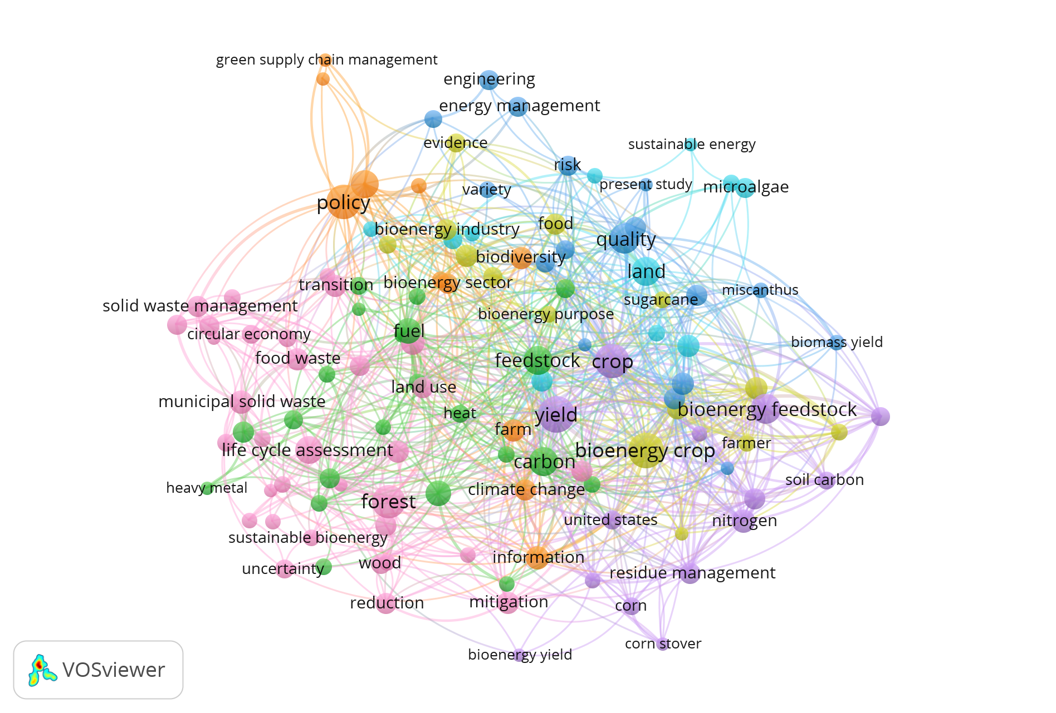

**Figure 1.** Network Visualization of Management Bioenergy

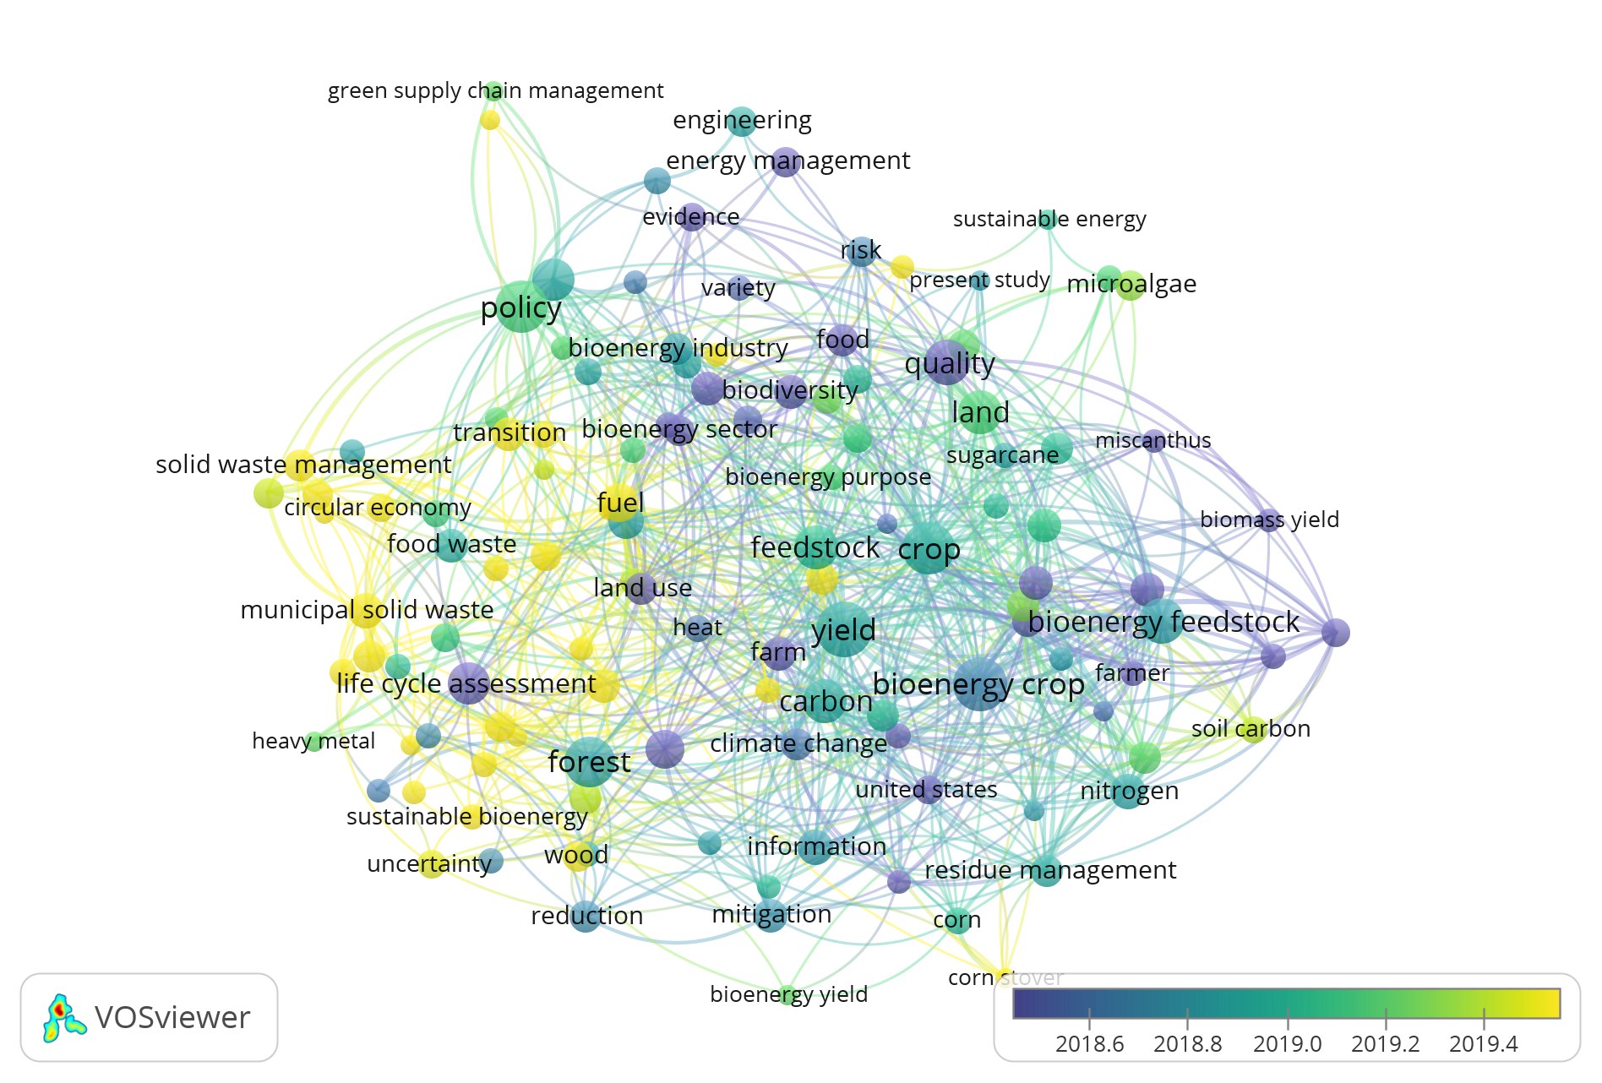

**Figure 2.** Overlay Visualization of Management Bioenergy

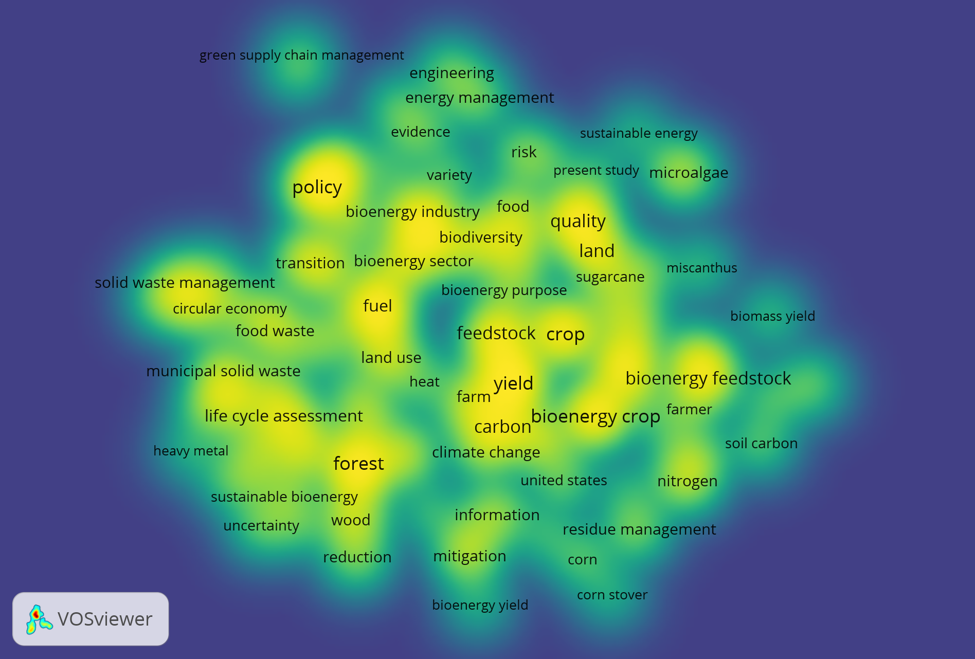

**Figure 3.** Density Visualization of Management Bioenergy

Each cluster contains a relationship between two terms. Forest is the most commonly used term in Cluster 1 as a research topic for bioenergy management. According to the Figure 4, forests are linked to 15 other terms. Policy, bioenergy sector, land, improvement, heat, harvest, life cycle assessment, ghg emission, wood, mitigation, reduction, and uncertainty are all terms related to forest keywords. Carbon is the most widely discussed term in the field of bioenergy management in Cluster 2. Carbon is linked to 16 other terms in Figure 5. Policy, availability, land, pyrolysis, food waste, feedstock, biomass production, switchgrass, farm, valorisation, forest, information, mitigation, corn, residue management, and nitrogen are all terms related to the keyword carbon.

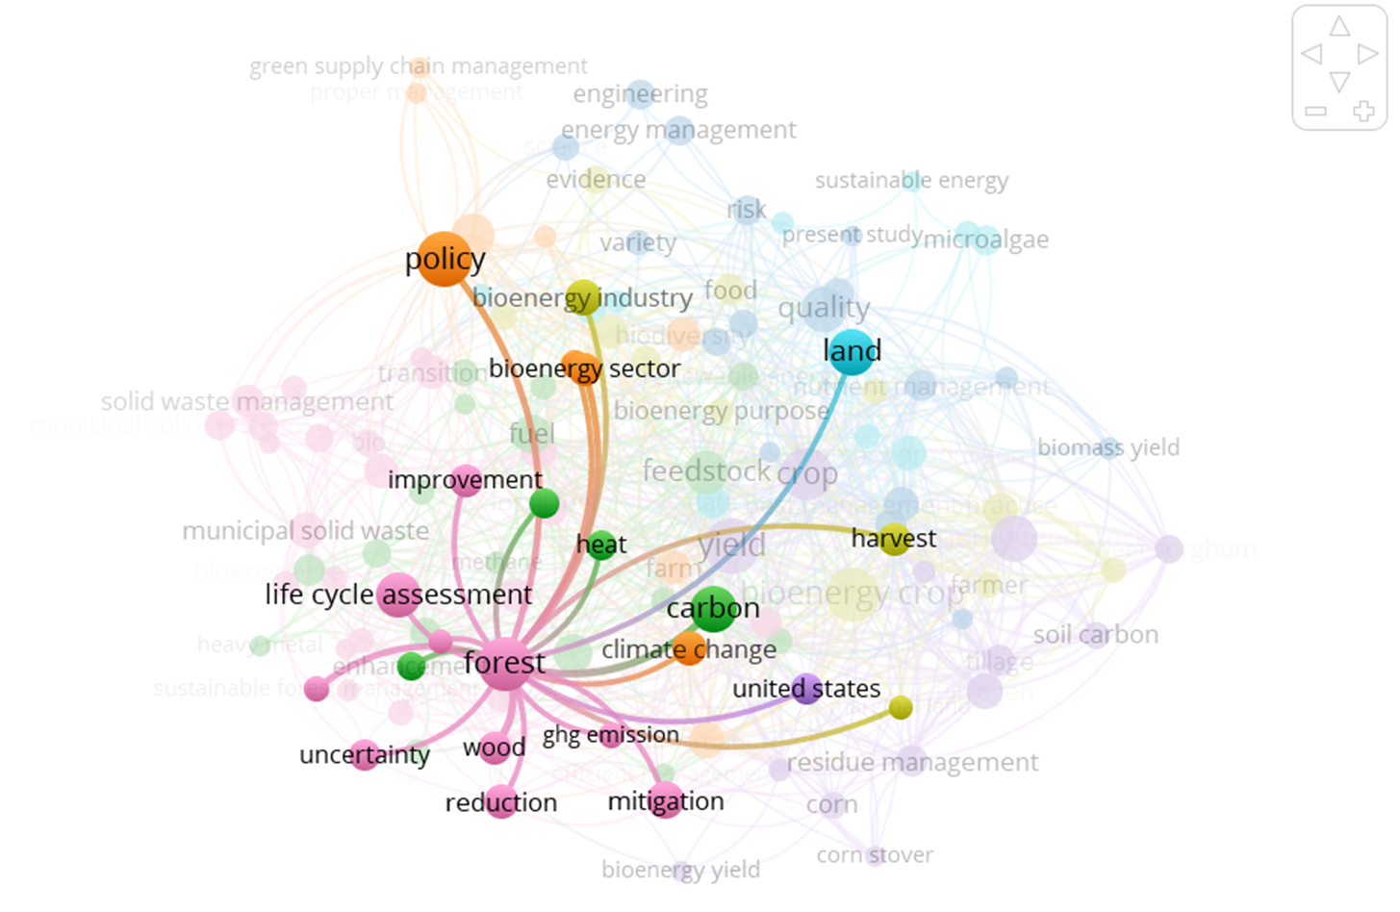

**Figure 4.** Network Visualization of Cluster 1

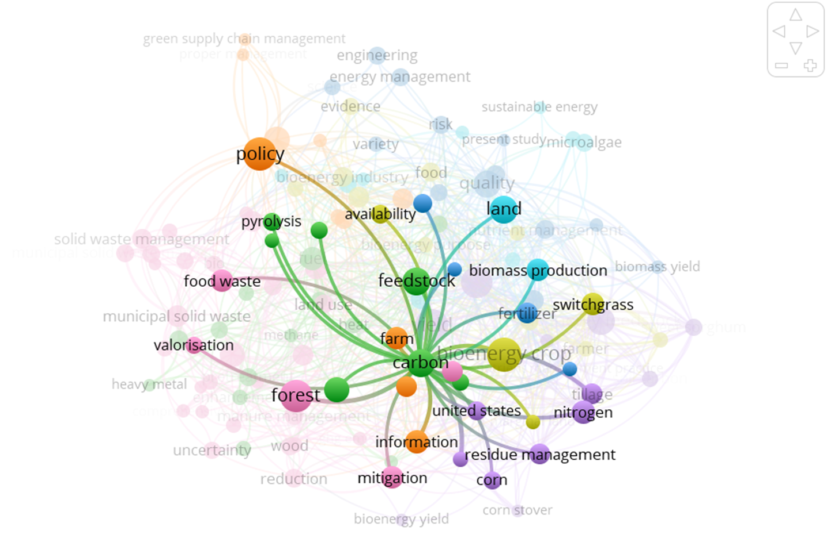

**Figure 5.** Network Visualization of Cluster 2

In cluster 3, quality is at the centre of the term that is most commonly used as a research topic for bioenergy management and has numerous connections with other terms. According to the graph, quality is linked to 15 other terms (see Figure 6). Evidence, risk, variety, gasification, policy, measure, land use, feedstock, biomass production, nutrient management, biomass yield, yield, bioenergy crop, bioenergy feedstock, and residue management are all quality keywords. Meanwhile, in Cluster 4, the bioenergy crop becomes the main centre of the term that is most frequently raised as a topic of research on bioenergy management and has numerous connections with other terms. Figure 7 depicts the relationship between bioenergy and other words. Figure 7 depicts the relationship between bioenergy crops and 27 other crops. Figure 7 shows how bioenergy crop is linked to 27 other concepts. Risk, bioenergy industry, food, biodiversity, quality, land, surgance, crop, miscanthus, biomass yield, bioenergy feedstock, farmer, soil carbon, nitrogen, corn, nitrogen management, mitigation, information, climate change, carbon, farm, yield, land use, reduction, enhancement, biofuel production, and heavy metal.

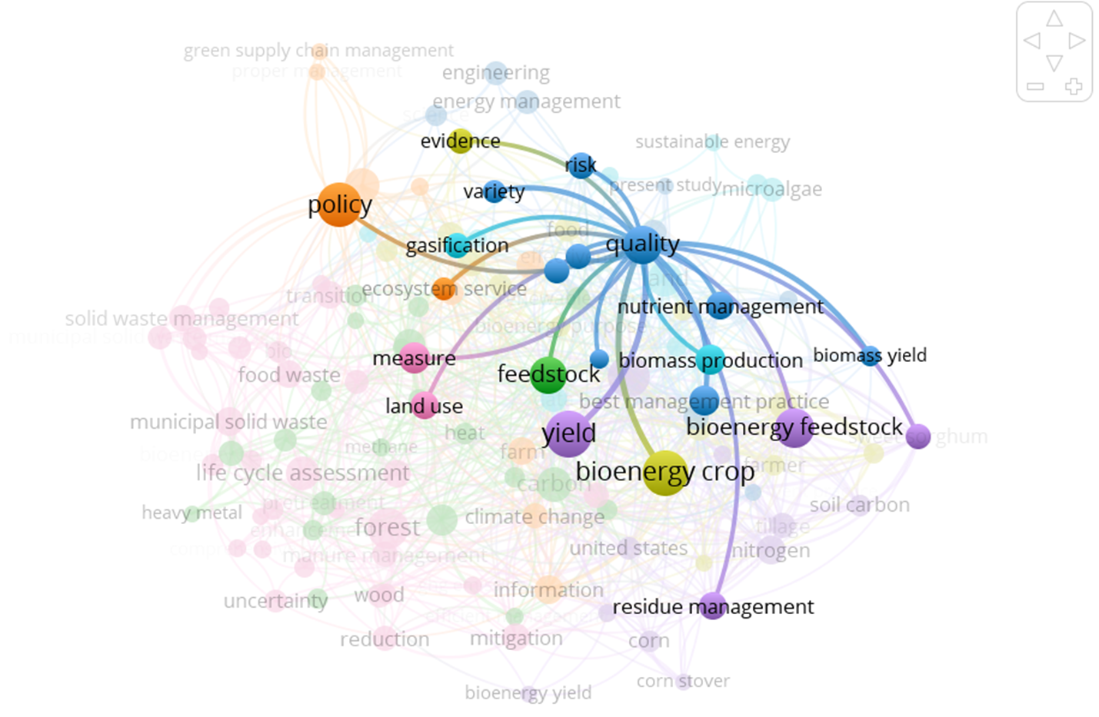

**Figure 6.** Network Visualization of Cluster 3

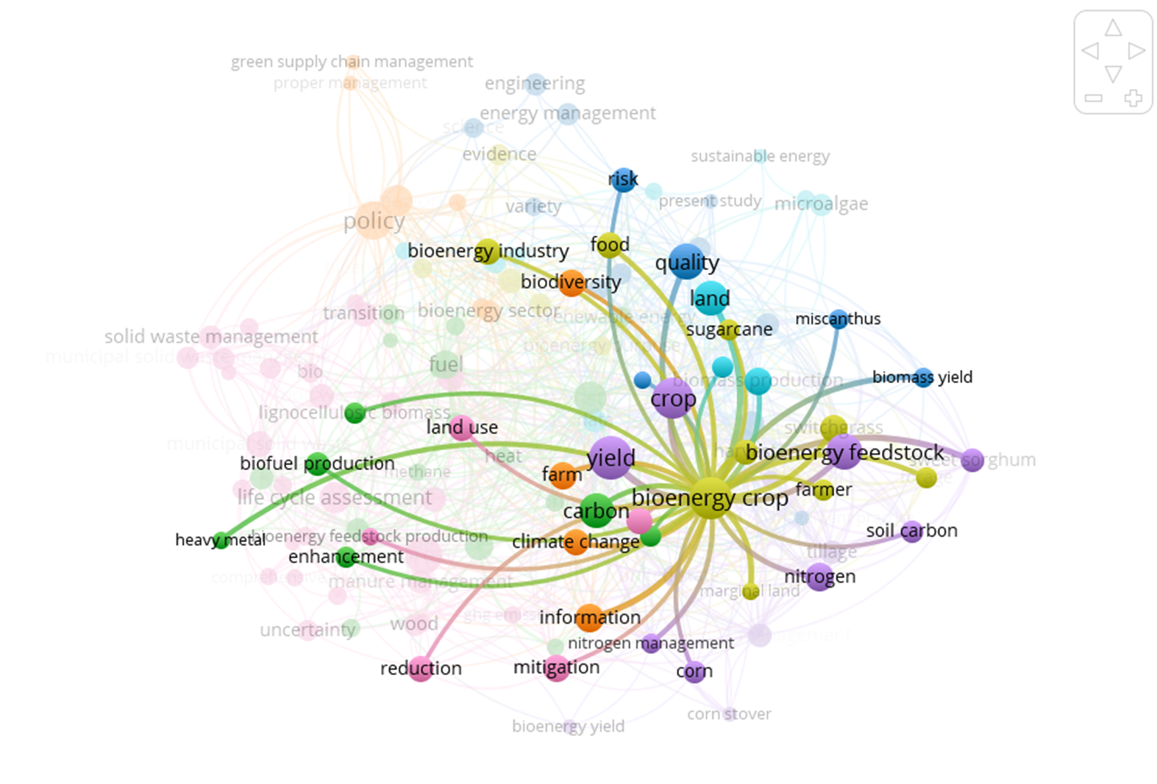

**Figure 7.** Network Visualization of Cluster 4

In cluster 5, yield is the centre point of the term that is most widely used as a research topic for bioenergy management and has numerous connections to other terms. According to the diagram, yield is linked to 22 other terms. Risk, current study, quality, implication, bioenergy sector, nutrient management, crop, feedstock, land use, biofuel production, sustainable bioenergy, uncertainty, reduction, climate change, information, mitigation, corn, residue management, corn stover, bioenergy crop, tillage, and bioenergy feedstock are all terms related to yield keywords. In cluster 6, land is the center point of the term that is most frequently used as a research topic for bioenergy management and has numerous connections to other terms. According to Figure 10, land is linked to 14 other terms. Sustainable energy, biodiesel, framework, bioenergy potential, biodiversity, pyrolysis, land use, data, crop, forest, bioenergy crop, bioenergy feedstock, biomass yield, and nitrogen are all terms related to land. Meanwhile, in Cluster 7, policy becomes the focal point of the term that is most widely used as a research topic on bioenergy management and has many connections to other terms. Figure 9 depicts the relationship between policy and other words. Figure 9 depicts the relationship between policy and ten other concepts, including green supply chain management, energy management, quality, biodiversity, transition, land use, food waste, life cycle assessment, carbon, and forests.

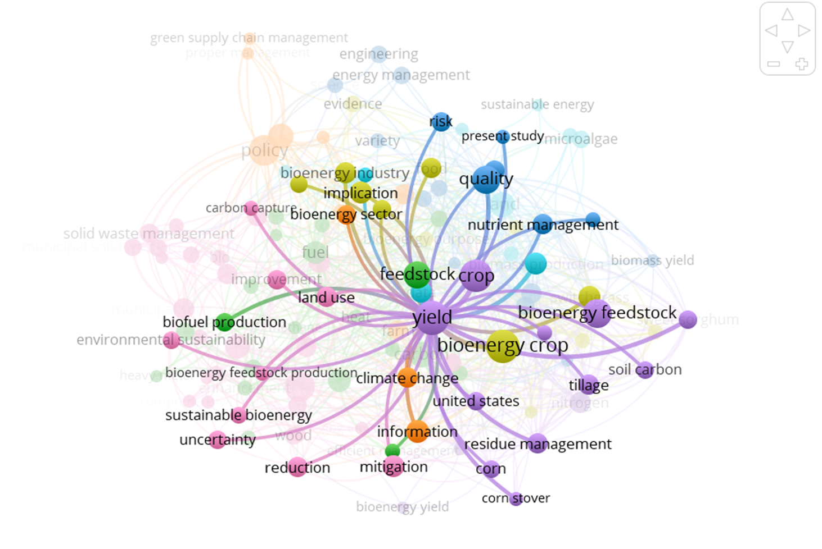

**Figure 8.** Network Visualization of Cluster 5

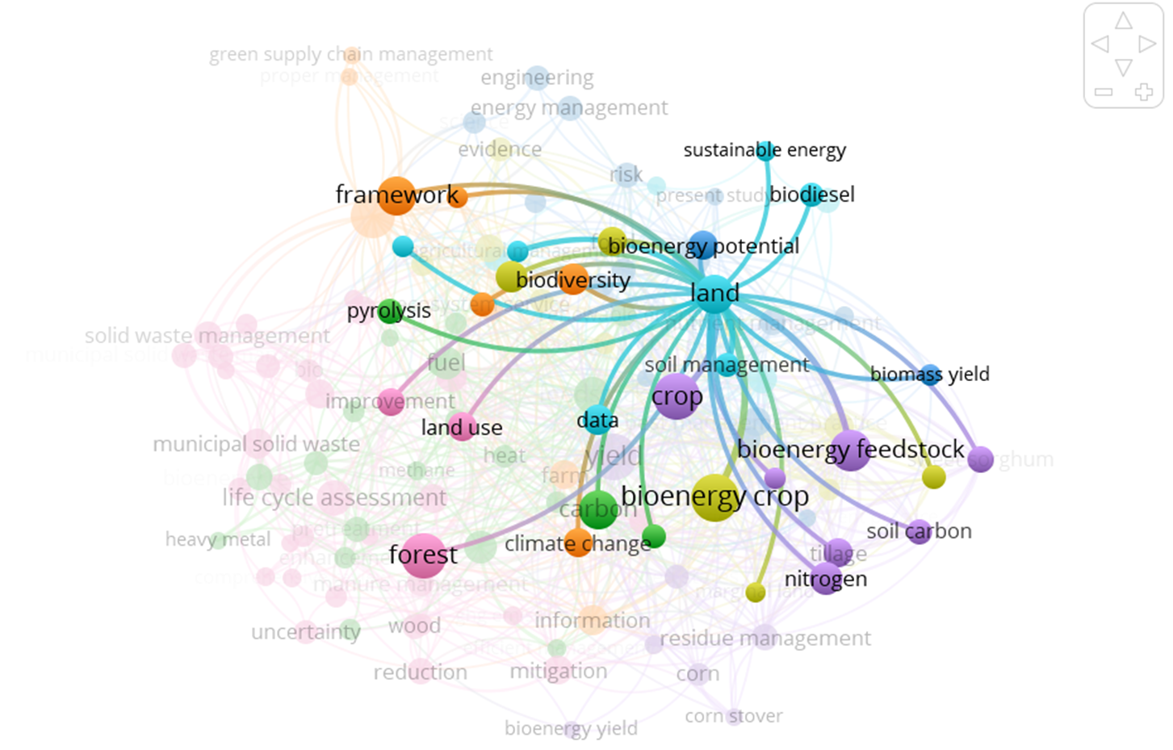

**Figure 9.** Network Visualization of Cluster 6

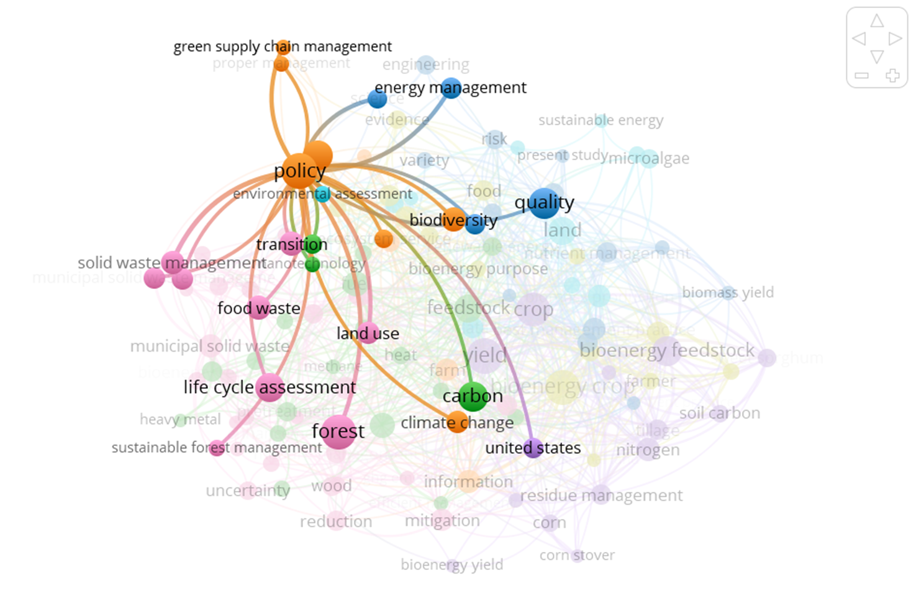

**Figure 10.** Network Visualization of Cluster 7

**Conclusion**

The purpose of this research was to examine the bibliometric literature on bioenergy management. In this study, bioenergy was divided into two categories: bioenergy crop and bioenergy feedstock. In the search process, the keyword "management bioenergy" is used, which is based on a topic area with titles, keywords, and abstracts. Following the search, 900 articles were discovered to be relevant. The mapping procedure is then completed using VOSviewer. The search yielded 15 papers with the most citations. Based on the results of analysis and mapping with VOSviewer, bioenergy management research with term study was identified as the most studied in the 2017-2021 period. Meanwhile, the bioenergy crop is the most researched in the field of bioenergy management. The VOSviewer analysis identified seven keyword clusters related to the research topic of bioenergy management. Each cluster contains a main term that is linked to other terms. Forest, Carbon, Quality, Bioenergy Crop, Yield, Land, and Policy are all terms found in Cluster 1. Meanwhile for Cluster 2-7, the term included is Forest, Quality, Bioenergy Crop, Yield, Land, and Policy, respectively.

**References**

[1] D. F. Al Husaeni, A. B. D. Nandiyanto, Bibliometric using Vosviewer with Publish or Perish (using google scholar data): From step-by-step processing for users to the practical examples in the analysis of digital learning articles in pre and post Covid-19 pandemic. *ASEAN Journal of Science and Engineering*, 2(1) (2022) 19-46.

[2] N. J. Van Eck, L. Waltman, Citation-based clustering of publications using CitNetExplorer and VOSviewer. Scientometrics, 111(2) (2017) 1053-1070.

[3] I. Hamidah, S. Sriyono, M. N. Hudha, A Bibliometric analysis of Covid-19 research using VOSviewer. *Indonesian Journal of Science and Technology*, 5(2) (2020) 209-216.

[4] K. A. Y. A. Mustafa, E. Erbay, Global trends of the researches on Covid-19: A bibliometric analysis via VOSviewer. *Ankara Sağlık Bilimleri Dergisi*, 9(2) (2020) 201-216.

[5] N. H. Beebe, A Complete Bibliography of Publications in the Journal of Statistical Theory and Practice. Algorithms, 630(723) (2021) 208.

[6] Y. Y. Al-Ashmori, I. Othman, Y. Rahmawati, Bibliographic analysis of BIM success factors and other BIM literatures using Vosviewer: a theoretical mapping and discussion. In Journal of Physics: Conference Series, 1529(4) (2020, April) 042105.

[7] E. Orduña-Malea, R. Costas, Link-based approach to study scientific software usage: The case of VOSviewer. *Scientometrics*, 126(9) (2021) 8153-8186.

[8] S. K. Rose, E. Kriegler, R. Bibas, K. Calvin, A. Popp, D. P. van Vuuren, J. Weyant, Bioenergy in energy transformation and climate management. *Climatic Change*, 123(3) (2014) 477-493.

[9] N. J. Eck, L. Waltman, Software survey: VOSviewer, a computer program for bibliometric mapping. *Scientometrics*, 2(84) (2010) 523-538.

[10] N. J. Van Eck, L. Waltman, Text mining and visualization using VOSviewer. *arXiv preprint* arXiv:1109. (2011) 2058.

[11] B. Williams, Dimensions & VOSViewer bibliometrics in the reference interview. *Code4Lib Journal*, (47) (2020).

[12] Y. Hu, Z. Sun, D. Wu, Analysis of hot topics in soil remediation research based on VOSviewer. In IOP Conference Series: *Earth and Environmental Science* 300(3) (2019, July) 032098.

[13] T. Huang, H. Wu, S. Yang, B. Su, K. Tang, Z. Quan, X. Luo, Global trends of researches on sacral fracture surgery: a bibliometric study based on VOSviewer. *Spine*, 45(12) (2020) E721-E728.

[14] R. Gabriella, M. A. N. Zen, F. I. Haq, S. R. Putri, A. B. D. Nandiyanto, Techno-Economic Analysis of NiFe2O4 Nanoparticle Industry Using Sonochemical Synthesis Method. *International Journal of Research and Applied Technology (INJURATECH).* 1(2) (2021) 65-75.

[15] Z. N. Ansari, R. Kant, A state-of-art literature review reflecting 15 years of focus on sustainable supply chain management. *Journal of cleaner production*, 142 (2017) 2524-2543.

[16] G. Baryannis, S. Validi, S. Dani, G. Antoniou, Supply chain risk management and artificial intelligence: state of the art and future research directions. *International Journal of Production Research*, 57(7) (2019) 2179-2202.

[17] Y. Wang, C. Wang, X. Song, M. Huang, S. K. Megarajan, S. F. Shaukat, H. Jiang, Improved light-harvesting and thermal management for efficient solar-driven water evaporation using 3D photothermal cones. *Journal of Materials Chemistry A*, 6(21) (2018) 9874-9881.

[18] N. Pavlineri, N. T. Skoulikidis, V. A. Tsihrintzis, Constructed floating wetlands: a review of research, design, operation and management aspects, and data meta-analysis. *Chemical Engineering Journal*, 308, (2017)1120-1132.

[19] G. Strazzera, F. Battista, N. H. Garcia, N. Frison, D. Bolzonella, Volatile fatty acids production from food wastes for biorefinery platforms: A review. *Journal of environmental management*, 226 (2018) 278-288.

[20] R. Ghimire, S. Lamichhane, B. S. Acharya, P. Bista, U. M. Sainju, Tillage, crop residue, and nutrient management effects on soil organic carbon in rice-based cropping systems: A review. *Journal of integrative agriculture*, 16(1) (2017) 1-15.

[21] C. Zhang, G. Zeng, D. Huang, C. Lai, M. Chen, M. Cheng, R. Wang, Biochar for environmental management: Mitigating greenhouse gas emissions, contaminant treatment, and potential negative impacts. *Chemical Engineering Journal*, 373 (2019) 902-922.

[22] P. de Camargo Fiorini, C. J. C. Jabbour, Information systems and sustainable supply chain management towards a more sustainable society: Where we are and where we are going. *International Journal of Information Management*, 37(4) (2017) 241-249.

[23] T. E. Seiple, A. M. Coleman, R. L. Skaggs, Municipal wastewater sludge as a sustainable bioresource in the United States. *Journal of Environmental Management*, 197 (2017) 673-680.

[24] C. Kammann, J. Ippolito, N. Hagemann, N. Borchard, M. L. Cayuela, J. M. Estavillo, N. Wrage-Mönnig, Biochar as a tool to reduce the agricultural greenhouse-gas burden–knowns, unknowns and future research needs. *Journal of Environmental Engineering and Landscape Management*, 25(2) (2017) 114-139.

[25] T. Wallace, D. Gibbons, M. O'Dwyer, T. P. Curran, International evolution of fat, oil and grease (FOG) waste management–A review. *Journal of environmental management*, 187 (2017) 424-435.

[26] R. M. Jingura, R. Kamusoko, Methods for determination of biomethane potential of feedstocks: a review. *Biofuel Research Journal*, 4(2) (2017) 573-586.

[27] T. L. Skovhus, R. B. Eckert, E. Rodrigues, Management and control of microbiologically influenced corrosion (MIC) in the oil and gas industry—Overview and a North Sea case study. *Journal of Biotechnology*, 256 (2017) 31-45.

[28] M. Triviño, T. Pohjanmies, A. Mazziotta, A. Juutinen, D. Podkopaev, E. Le Tortorec, M. Mönkkönen, Optimizing management to enhance multifunctionality in a boreal forest landscape. *Journal of Applied Ecology*, 54(1) (2017) 61-70.

[29] N. Pour, P. A. Webley, P. J. Cook, Potential for using municipal solid waste as a resource for bioenergy with carbon capture and storage (BECCS). *International Journal of Greenhouse Gas Control*, 68, (2018) 1-15.

[30] D. F. Al Husaeni, A. B. D. Nandiyanto, Mapping Visualization Analysis of Computer Science Research data in 2017-2021 on the Google Scholar database with VOSviewer. *International Journal of Informatics, Information System and Computer Engineering (INJIISCOM)*, 3(1) (2023) 1-18.

[31]